Cloverleaf High School Class of 1962 50th Reunion August, 2012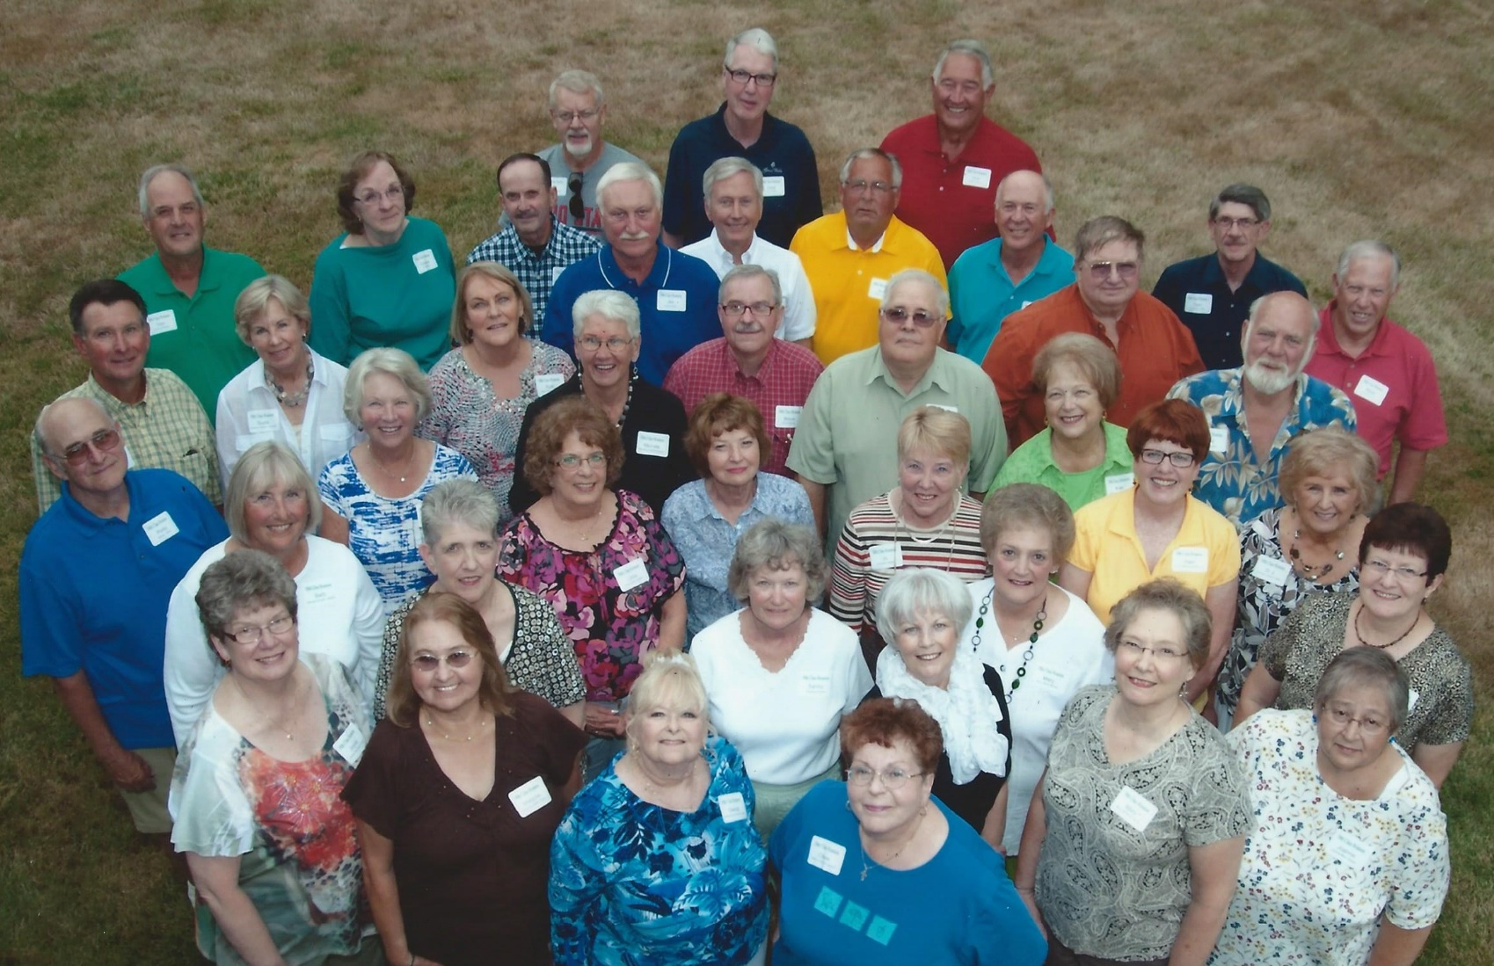
Man Alive…it’s 55 with a Special Invitation
On August 11 and 12, 2017 we will be celebrating our 55th class reunion for the Cloverleaf Class of 1962 and we hope you will be a part of it.
Do you believe that it was 55 years ago that we put on those silly looking robes and marched into the gym to receive our fake leather covers with our official diploma inside? That night of our lives separated from walking the halls together to families, careers and continued friendships. It is now time to bring us back together to celebrate those special memories and have some fun too.
We ask you to make a special effort to return for our 55th anniversary celebration.
The enclosed newsletter has all of the “scoop” for both Friday and Saturday’s activities and events so get your reservation form completed and mailed in immediately if not sooner or by June 15, 2017 for sure.
We sure hope you can join us…you will not be disappointed! The Reunion Committee

'62 | Cloverleaf High School  55th Class REUNION  Newsletter

First Issue/Page 1 March/2017
Our 55th Reunion Calls for Relaxing
Week-End of Good Times and Fellowship

After a very successful 50th reunion in 2012, the Reunion Committee has planned a week-end to enjoy a relaxed atmosphere of events and renewing those funny stories of Cloverleaf happenings and Lodi dances….except now you can tell them again because no one remembers if you told them or not!

Festive Fun and Friendship on Friday/August 11

The committee has decided to take this popular evening to a new location called Krabill Shelter. It will be an excellent facility for us and is part of the Medina County Parks District. For those that swam at Westfield Landing (across the lake from Chippewa Park) it is part of that “old swimming hole”.
We will have the event catered by Buehler’s Fresh Foods with a Smokehouse BBQ of chicken and pulled pork including all the great sides that go with it.
Please arrive around 5:22 PM with dinner served at approximately 6:27 PM. The Krabill Shelter is located at 7597 Ballash Road, Medina, OH.
The cost is $20.00 per person if you attend Friday Night only. We encourage you to attend both nights. See the “55 Reunion Special Combo” prices on page 2.
A map and complete details will be in the June newsletter….also to help keep costs reasonable we are asking for $25.00 “Colt Contributor” sponsors to cover the cost of beverages and snacks for this event.

First Issue/Page 2 March/2017
Goin’ to the Galaxy on Saturday/August 12
Thanks to new reunion committee member Diane (Fulton) Anderson, we have secured the Galaxy Banquet Center on Saturday evening. It is a beautiful facility with an excellent reputation for excellent food and service.
We have selected the Elegant Dinner Buffet and the cost will be $45.00 per person.
We will have a social hour less 15 minutes starting at 5:33 PM with a cash bar and a couple of appetizers. Dinner will follow. See the special “55 Reunion Special Combo” prices if you attend both Friday and Saturday events.
The Galaxy location is 201 Park Centre Drive, Wadsworth, OH. An informal program will follow dinner and prizes will be awarded for those that can stay up past 9:00 PM.

Accommodations Set For Friday and/or Saturday Nights

For those classmates traveling from out-of-state or several miles from home, we have made special hotel arrangements for you either Friday and/or Saturday. Rooms have been reserved at the Comfort Inn and Suites at 5 Park Center Drive, Wadsworth, OH. A special reunion rate has been secured for $109.00 plus tax per night. Your reservation must be secured by Wednesday, July 12, 2017 to receive this rate. YOU ARE RESPONSIBLE FOR MAKING YOUR OWN RESERVATION! A great benefit to staying at the “Reunion Headquarters” is that it is right beside (easy walk) to the Galaxy Banquet Center where our Saturday reunion gala will be held. Please call the hotel directly at 330.336.7692. For those classmates staying over on Saturday night, we will have details for a great Sunday Brunch at the Galaxy in the next newsletter. _________________________________________________________________________________

“55 REUNION SPECIAL COMBO”
To encourage your attendance at both events, we have the “55 REUNION COMBO SPECIAL” offering. Since this is celebrating 55 years we have set the cost at $55.00 per person for both events. If you only come on Friday you pay $20.00 and selecting only Saturday the cost is $45.00 per person…so if you are paying attention you understand that you will save 10 bucks by joining us for both Friday and Saturday nights.

First Issue/Page3 March/2017
CAN YOU HELP BE A SPECIAL $25 “COLT CONTRIBUTOR” Sponsor?

With very few dollars in our reunion account, and trying to keep the event costs as reasonable as possible, we are asking for each classmate to consider stepping up to be a $25.00 “COLT CONTRIBUTOR” sponsor. These important support dollars would be used for beverages, soft drinks and snacks on Friday and to purchase appetizers for the social hour less 15 minutes on Saturday. We would like to get 16 sponsorships to insure that honest Bill Heffelfinger is not overdrawn in the reunion checkbook.

Please add the “COLT CONTRIBUTOR” check mark one the registration sheet and yes…..you sure can provide more than one sponsorship!

CLASS REUNION PHOTO AND NO REUNION BOOKLET

The tradition of the reunion class photo will continue with the gathering of this elite group on Friday night at the Krabill Shelter before dinner. This way no one will have dribbled food on them before our great meal!
Be sure to be at Krabill Shelter by 6:05 PM to be included in the class photo.
The photo cost will be $12.00 and will include the mailing and the names of those classmates in the picture.

The committee has decided that we will not do a reunion booklet. It is a lot of work and very expensive to print so you will need to attend to gather updates in our “what’s up with you” session after dinner at both events.

Friday Golf Outing Plans to be Finalized Soon
We have had a great response to the Friday golf outing for the past several reunions and we want to continue offering this fun event. We are still trying to work out details on a course so if you are interested in playing please mark the registration sheet and we will get back to you on specific detail of the course, times and green fees.

Committee Information:
Bill Heffelfinger | 330.769.2799 | whheff69@aol.com
Glynice/Porky Miller | 330.887.3121 | gamiller@aol.com
Bob Brown | 419.606.3457
Diane Anderson | 330.769.3615
Wink DeVaul | 419.289.7355 | winkd@zoominternet.net
Dick/Joan Anderson | 330.948.1295
Cloverleaf High School Class of 1962
55th Class Reunion Registration Form

Name _______________________________________ Phone (____)_________________

Address _________________________ City _______________ St ____ Zip ___________

E-Mail Address __________________________________

Maiden Name (if applies) __________________________ Spouse’s/Guest Name __________________________

Please complete the “Sign-Up Line-Up”:

_______ Please send me golf information being planned for Friday, August 11.

1 2 3 4 Circle how many will play. You will be notified of green fees, course and tee times.
_____________________________________________________________________________________________

“55 REUNION COMBO” REGRISTRATION
______ I/We will attend both Friday and Saturday events.
Number of reservations _____ X $55 each = $_____________
________________________________________________________________________________

FESTIVE FRIDAY OF FUN & FRIENDSHIP AT KRABILL SHELTER REGISTRATION ONLY

_______ I/We will only attend the Friday Night event.
Number of reservations _____ X $20 each = $______________
_____________________________________________________________________________________________

GOIN’ TO THE GALAXY ON SATURDAY NIGHT ONLY

_______ I/We will only attend the Saturday night buffet event.
Number of reservations _____ X $45 each = $______________
________________________________________________________________________________
“COLT CONTRIBUTOR” SPONSORSHIP
______ I/We would like to provide sponsorship(s) at $25 each to help provide financial help for the events. Number of sponsorships _____ at $25 each =_____________
_____________________________________________________________________________________________
Class Photo

_______ I/We would like to purchase a 55th reunion class photo @ $12.
_________________________________________________________________________________

OK…. Now put your math skills learned at CHS to work and add up how much money you owe for registrations and maybe a photo:

Total amount due: $___________________________

Page 2 of Registration Form

55th Reunion Registration Time Line

- We encourage you to complete your registration form now and enclose your total amount due…….or complete your registration form now and mail…… your payment can be made later but no later than June 15, 2017 to confirm your attendance and for the committee to prepare for reservations.

- If you have any questions concerning the 55th reunion, please contact one of the committee members by phone or e-mail.

REGISTRATION Mailing:

Make checks payable to: Class of ‘62 Reunion/ Honest Bill Heffelfinger, Treasurer

Mail Payment Registration to: Glynice Miller
PO Box 642
Westfield Center, OH 44251

……………………………………………………………………………………………………………………………………
(Cut Here)

Reunion Prize Patrol

The “Reunion Prize Patrol” needs donations for the fund raising raffle at the Fun
and Friendship Friday night. You can provide prizes through your business
or personal talents; gift certificates, etc. You can bring them with you on Friday
night or give them to any committee member in advance. We would like to know
if you are planning to contribute even if you do not know exactly what that might
be now.

Item(s):________________________________________________________ _______________________________________________________________

Be sure to detach and mail this Reunion Prize Patrol information with your Registration Form.

