Show support for the national playoff bound Cloverleaf High School & Middle School Academic Challenge Teams with the purchase of “Nerd Herd” t-shirts. The artwork for the “Nerdy Colt” was donated by local artist Jim Gill.

Shirts are short sleeve dark heather gray. Sizes S-XL cost $15, and XXL are $17.
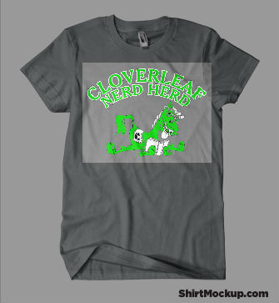
NOTE: Lighter gray box around “Nerdy Colt” will not be on the shirt. Shirt will be a all one color.

Proceeds support the CHS team’s trip to the High School National Championship Tournament-Atlanta & CMS’s trip to Dallas for the Middle School National Championship Tournament.

Name_________________________________________CHS CMS CES Central Office (circle one)

Address_______________________________________(FOR DELIVERY IF NOT ON CAMPUS)

Number of Shirts & Sizes:____________________________

Total $____________________________________________

- Make checks payable to Cloverleaf Academic Challenge Team.
- Please send this form and payment to Cameron Flint-Cloverleaf High School.

ORDERS & PAYMENT ARE DUE BY
WEDNESDAY MAY 10

THANK YOU FOR SUPPORTING THE “NERD HERD”!

